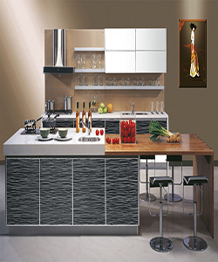

Readymade kitchen cabinet solid rubber wood

$424.83

Availability: In stock

### Description

Durian Kitchen cabinet door panel finish. The material is a strong, tightly-wrapped and heat-sealed seamless plastic that produces a beautiful uniform appearance that is resilient, easy-to-care for and impervious to stains. The smooth-surfaced doors are custom made to your kitchen project, and are available in a range of sheen levels, colors and wood grain textures. Solid wood doors have inherent natural colors and variations that present a number of beautiful possibilities for your room. Our wood cabinet doors come in a wide range of stylish variations, including cherry, hickory, maple, birch and red oak. For more options, please contact our sale staff